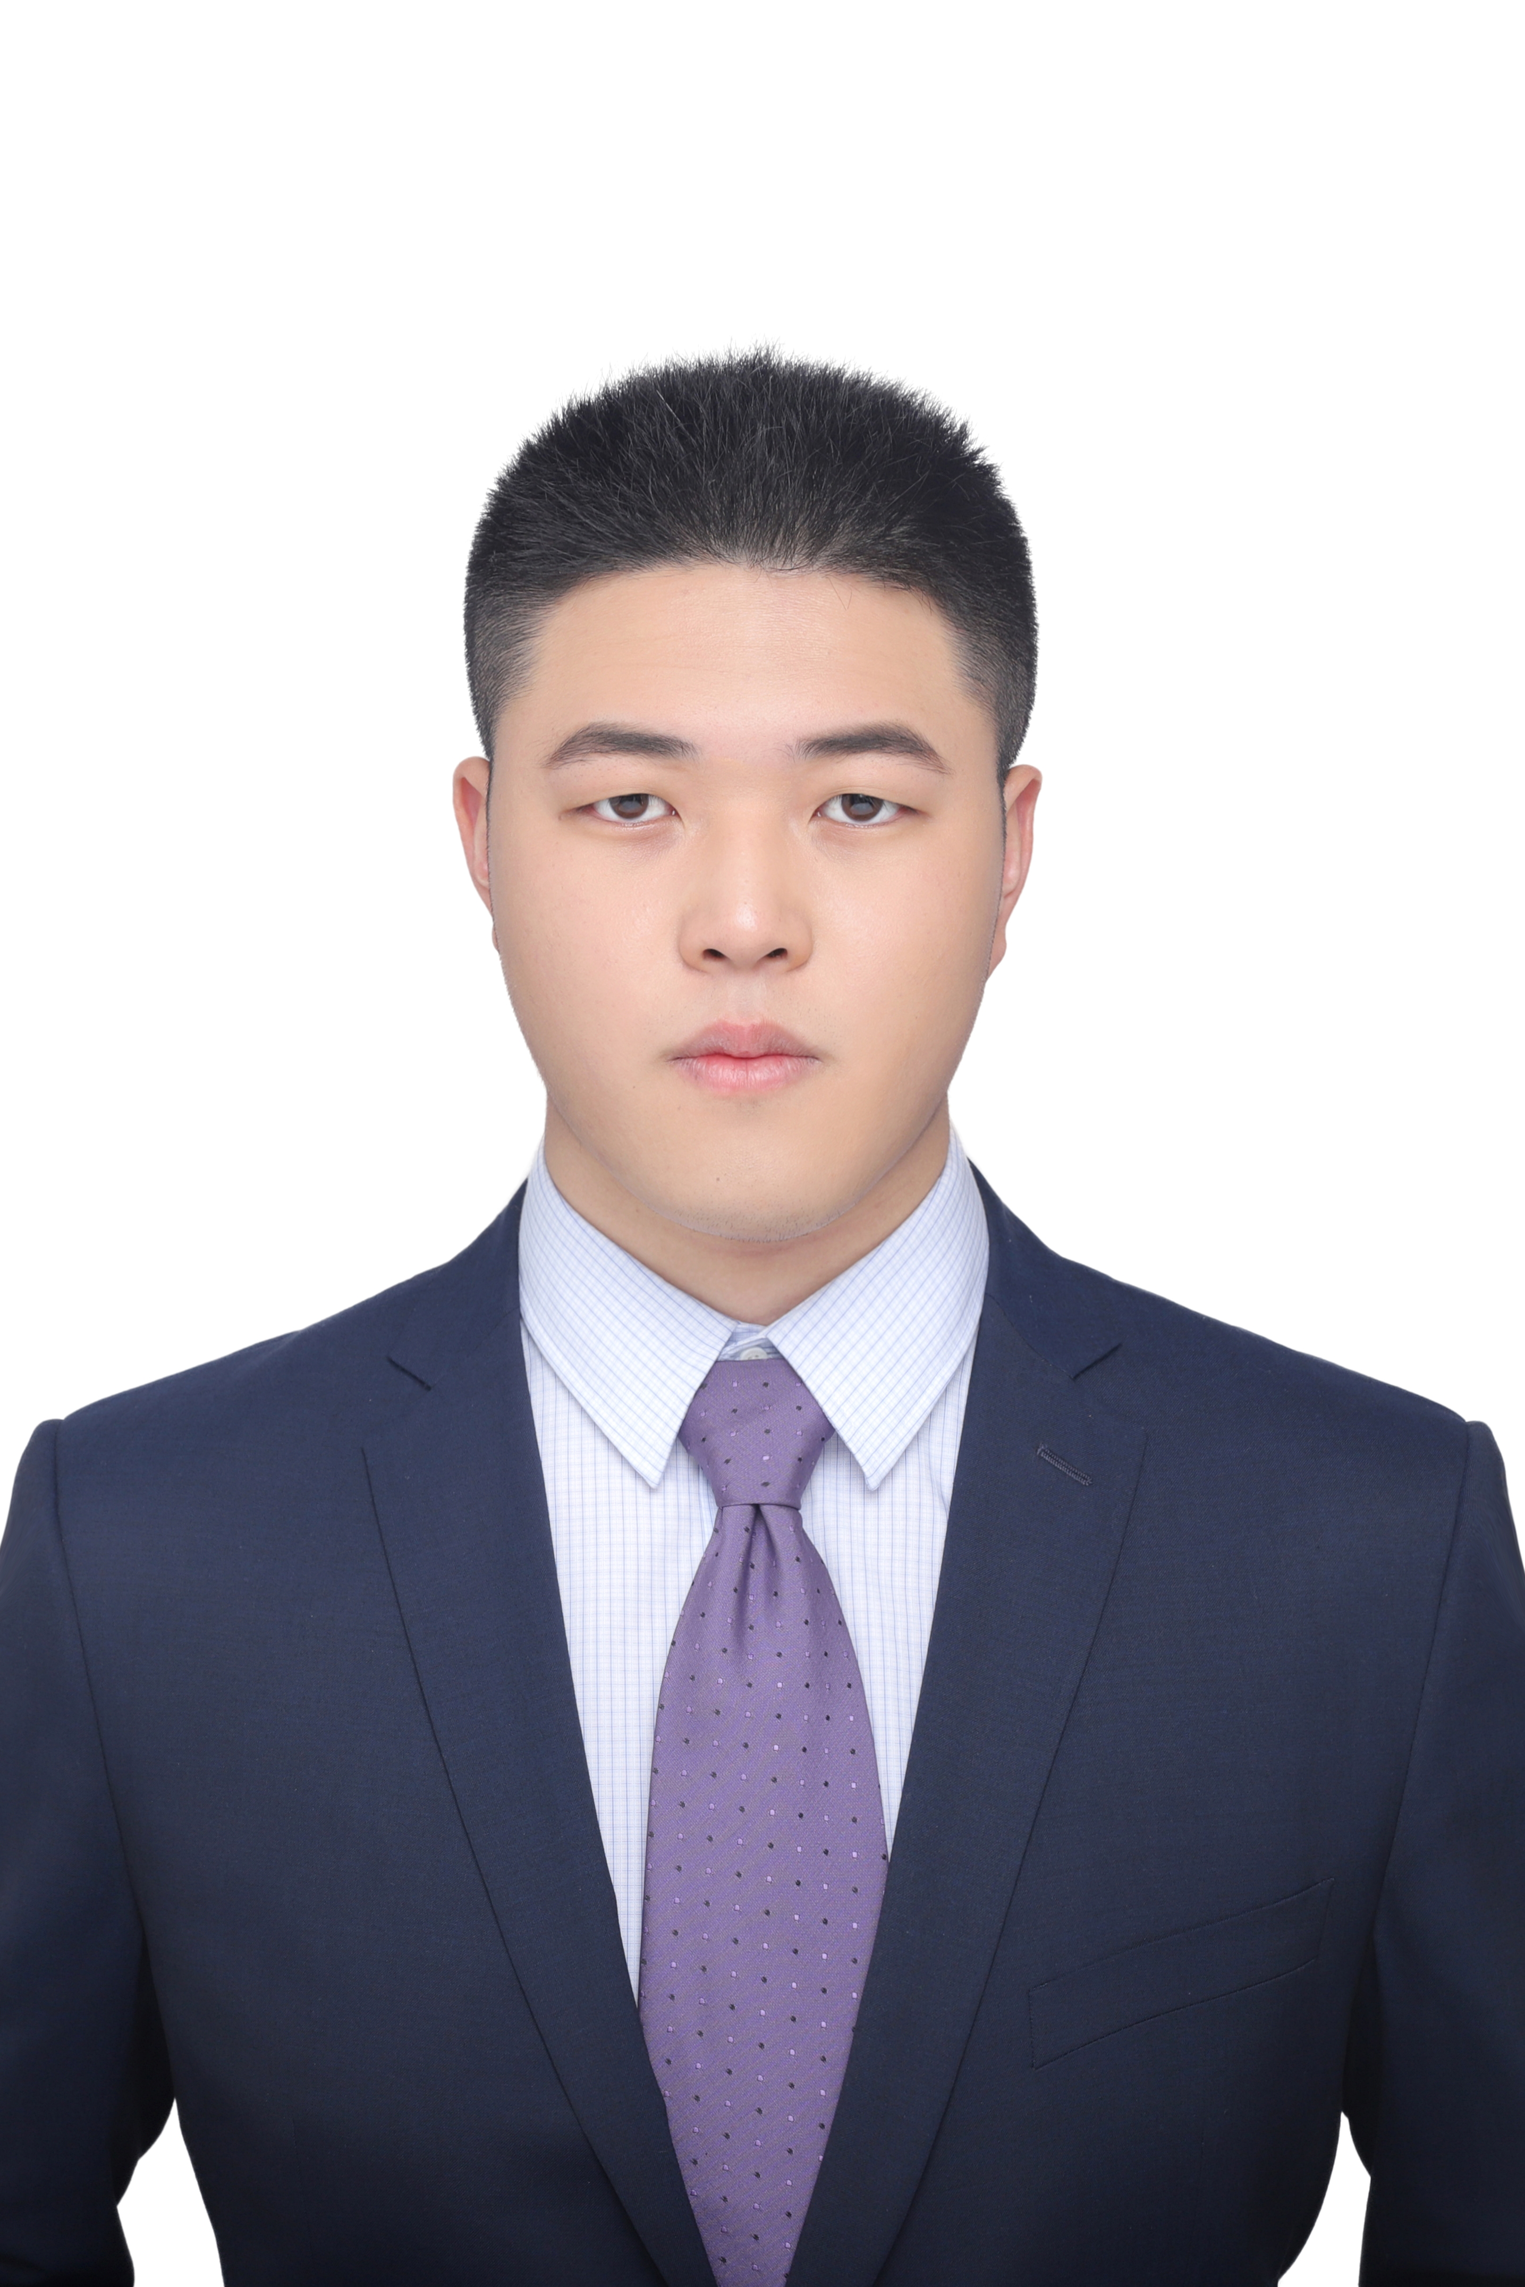**Ju Zhizheng**

+86 18751861206 | [jerryju@connect.hku.hk](mailto:jerryju@connect.hku.hk)

LinkedIn: [www.linkedin.com/in/zhizheng-ju-hku2025](http://www.linkedin.com/in/zhizheng-ju-hku2025)

**Education Background**

**Nanjing Agricultural University（211 Project） Nanjing, Jiangsu, China**

Bachelor Degree; Major: Statistics 2019.09-2023.06

* **GPA:** 87.64/100
* **Related Courses:** C language program and experiment (95), R language (88), Econometrics (90), Business English audio-visual speaking (95), Corporate Finance (85), Security Analysis and Investment (88)

**The University of Hong Kong Hong Kong, China**

Master Degree; Major: Data Science 2023.09-2025.06

* **Related Courses:** Advanced database systems, Computational intelligence and machine learning, Financial fraud analytics, Time series forecasting, Marketing analytics, Deep Learning, Financial data analysis

**Internship Experience**

**Deloitte Education & Technology (Shenzhen) Co., Ltd. Shenzhen (2022.07-2022.09)**

**Consulting Intern**

**Main responsibilities:** Collected and summarized industry information, wrote consultancy proposals, liaised with the team externally and with various departments and foreign countries

**Working details:**

* Managed communications for the BRICS Women's Innovation Competition, engaging with global participants.
* Developed traisning materials for the China Baowu Group's international investments and digital transformation initiatives, including for CNPC and CITIC Pacific, and researched for KPC Pharmaceutical Group's global expansion.
* Facilitated Morning Pitch Asia's entry into China, working alongside Deloitte Japan DTVS.
* Played a key role in promoting and updating the Deloitte Training App.
* Represented management as a preliminary judge in the "Merchants Cup" innovation and entrepreneurship competition.
* Excelled in teamwork, multitasking, and leadership, earning high praise from colleagues..

**Shenzhen HTI Group CO., Ltd Shenzhen (2023.01-2023.02)**

**Industry & Investment Research Intern**

**Main responsibilities:** Assist the researcher to carry out industry research and investment research, and help the researcher to collect the required information and data for the research

**Working details:** (As the project is strictly confidential within the company, it is not possible to describe in detail)

* Participate in the investment research project of a large aircraft parts manufacturing enterprise
* Participate in a network platform investment research project
* Through searching and reading related research reports, the technology path and business model of the new energy automobile industry are sorted out, and innovative insights on the industry cycle are given.
* Completed the analysis of business plans of intelligent hardware, industrial software, Internet and other related industries and output corresponding summaries

**Penghua Fund Management Co., Ltd (Head Office) Shenzhen (2023.07-2023.09)**

**Assistant Financial Engineer**

**Main responsibilities:** Processing and analyzing financial data, using Hang Seng Juyuan, Wind, PL Oracle and Python

**Working details:**

* Code implementation and analysis of six sides of time timing radar, index analysis and screening of macro time timing tracking model
* Public offering fund industry research and fund tracking, fund performance attribution and performance evaluation
* Support investment research data and make data reports
* Quantitative Stock Industry allocation and asset allocation strategy research

**The University of Hong Kong Hong Kong, China (2023.09-2023.11)**

**Research Assistant (Quantitative Finance)**

**Main responsibilities:** Following Dr. Fangzhou Lu in the research of quantitative trading projects

**Working details:**

* Stock market quantitative trading model algorithm design
* Processes and analyzes the stock market data, and uses DBSCAN, Random Forest, Z-score function and time series analysis to establish the stock market outlier detection model.
* Designed the stock market quantitative trading model algorithm, established the LRC&MA model, which can display long and short signals, and compared the sensitivity of LRC and MA.
* Designed a quantitative trading system algorithm based on the support line resistance line of stock k chart

**CICC Wealth Management (Head Office) Shenzhen (2024.05-2024.06)**

**Product Research Intern**

**Main responsibilities:** Use Python and MySQL to develop financial data monitoring and early warning, analyze financial data using Wind API, complete monthly and weekly reports of fund products based on the corresponding data

**Working details:**

* Responsible for financial system data monitoring and early warning development & amp
* Responsible for the practical exploration and iterative update development of AI large model related applications in the team
* Responsible for multi-thread optimization of AI large model total control program
* Responsible for the analysis of financial market data (such as 3-year US Treasury data, fund position data, etc.) and the establishment of database

**Shenzhen Kaifeng Investment Management Co., Ltd. Shenzhen (2024.06-now)**

**Quantitative Asset Allocation Intern**

**Main responsibilities:** Use Python and SQL, and through Wind and other financial terminal data, apply statistical models, data mining, machine learning and other related technologies to carry out major asset allocation and financial model construction, optimize asset allocation, and write relevant financial engineering research reports

**Working details:**

* Participate in the simulation and testing of major asset allocation strategies, and conduct quantitative monitoring and evaluation of allocation effects;
* Establish risk exposure and risk exposure strategy models, establish CSI 300 dividend rotation strategies, and establish high-yield stock investment portfolios
* Construct valuation factors and funding factors, as well as executive stock repurchase strategies
* Establish stock entry and exit pool monitoring, and write weekly reports

**Project Experience and Club Activities**

**2021 American College Student Mathematical Modeling Competition Shanghai**

Responsible for most of the modeling and all the programming content

* Using Matlab and R language for data processing and algorithm code implementation and visualization.
* Many algorithms such as analytic hierarchy process, difference fitting and time series analysis are used to analyze and predict the data.
* Participation in essay writing and gave guidance and algorithm code explanation to the students who were in charge of writing to help them write the essay better.

**Study on Solutions of a Special Series of Yang-Baxter Matrix Equation Nanjing, Jiangsu**

**SRT Program**

* Responsible for organizing the team and contacting and looking for mentors. Responsible for the project team's proposal and mid-term project defense report.
* Based on the braid algorithm, we made innovative solutions to matrix equations under some special conditions, and the results can be directly or indirectly applied to the field of applied physics

**Algorithmic Trading of the US stock market based on Statistical and Machine Learning Models Hong Kong**

* Responsible for setting up project team and writing interim report
* Responsible for data pre-processing and training, backtesting method design
* Use deep learning (CNN, ResNet) and other methods to identify stock images and construct trading strategies

**Skills and Hobbies**

**Languages:** Chinese-mother tongue: Mandarin level 2 grade A; English-fluent: CET4: 599, CET6: 522, IELTS: 7， LSCAT 2nd Price of Jiangsu Province

**Skills:** Office, R studio, C Language, Matlab, Python, SQL, NoSQL, Oracle, Wind terminal, Hang Seng Juyuan terminal

**Certificates:** AMAC, FRM Level One Pass, CFA Level One Pass, CFA Level Two Candidate

**Volunteering:** Volunteer of Shenzhen Airport, Nanjing Chengxian Road community volunteer

**Hobbies:** Chess(Level 3 players), Chinese Go(Amateur level 4), Table tennis, Badminton, Photography, Debate (Represented the science class in the school debate competition in Senior high school), Movies(Big fan of Tom Cruse）